
Extended abstract Preparation guidelines
FOR MONGEOMETRIJA 2016
(Max. ARTICLE TITLE LENGTH: 5 lines; All letters capitalized; The title must be the same as that of the corresponding Full Paper; Times New Roman, 14pt, Bold; Spacing: Before: 20pt, After:10pt; No empty line below)
Akiro Takimoto
(Style of the paragraph: ‘<Author name’; Times New Roman, 10pt, Bold, Spacing: Before: 6pt, After: 0pt; No empty line below)
Affiliations, Knowledge Town, Republic of Success
PhD., Associate Professor, akiro@new.ac.ss
(Style of the paragraph: ‘<Correspondence details’; Each Appropriate Word With the First Letter Capitalized; Times New Roman, 10pt, Italic, Spacing: Before 5pt, After: 5pt; No Empty Line Below)
Peter Johanssen
(Style of the paragraph: ‘<Author name’; Times New Roman, 10pt, Bold, Spacing: Before 6pt, After: 0pt, no empty line below)
Affiliations, Lake City, Republic of Science
PhD., Assistant Professor, john@lab.ac.rs
(Style of the paragraph: ‘<Correspondence details’; Each Appropriate Word With the First Letter Capitalized; Times New Roman, 10pt, Italic, Spacing: Before: 5pt, After 5pt; No Empty Line Below)

INTRODUCTION (Style of the paragraph: ‘<heading1’; All letters capitalized; Times New Roman, 10pt, Bold, Spacing: Before: 12pt, After: 6pt; No empty line below).
These Preparation Guidelines aim to give to potential participants the necessary information relevant for the Extended Abstracts submission to the 5th ICGG Conference ‘Mongeometrija 2016’. These Guidelines ought to be respected so that each Extended Abstract submitted has a consistent appearance. This document itself is formatted according to the required Formatting-styles (names consist of symbol ‘<’ ). Since it is supplied as a Microsoft WinWord file, it can be used as a proper template. We, therefore, strongly suggest Authors to replace the content of this file with their own (preserving the existent page-setup/formatting and not adding any extra line-spaces i.e. blank rows, except in the case of usage ‘Page-breaking Rules’). To facilitate and simplify the formatting of paper, it is also possible to paste the complete content from another source/ document, and then format it by simple selecting the titles, text, captions, etc., and then clicking the appropriate Style from the Styles gallery, at the Home tab (top ribbon). (Style of the paragraph: ‘<First paragraph’, Times New Roman, 10pt, Regular, Spacing: Before: 6pt, Aafter: 0pt; No empty line below).
Two versions of the Conference Proceedings will be provided: (Spacing: Before: 5pt, After: 5pt)
- an electronic version (‘The Electronic Proceedings’), and
- a printed version (‘The Book of Abstracts’). (Style of the Paragraph: ‘<Bulleted list’; Spacing: Before: 6pt, After: 0pt)
The Electronic Proceedings will consist of all accepted Papers (in full) while the printed version will consist of Extended Abstracts only (as shortened versions of the corresponding Papers). (Style of the paragraph: ‘<New paragraph’,Spacing: Before: 6pt, After: 0pt).
The Extended Abstract (and its Paper) has to be written in English only. Both submitted documents will be reviewed prior to the final acceptance, and will be printed only if accepted. (Style of the paragraph: ‘<New paragraph’, Spacing: Before: 6pt, After: 0pt).
The Extended Abstract should be structured so as to gain: a concise description of the problem investigated, an application field that the problem belongs to, research stages performed in short, methods used in short and results obtained in short. The Extended Abstract and its Paper must have the identical Title as well as the authors’ order of appearance. (Style of the paragraph: ‘<New paragraph’, Spacing: Before: 6pt, After: 0pt).
The formatting styles that should be applied on the Extended Abstract and on its corresponding Paper are the same for all their sections that are in common. Generally, a text of both the Extended Abstract and the Paper has to be prepared identically - by Microsoft WinWord processor, using A4 (210 mm x 297 mm) single-column pages. The effective working area of each page is defined by the margins: Top - 2.5 cm, Bottom - 2.0 cm, Left – 2.0 cm, Right – 2.0 cm (Gutter - 1 cm, Left). Header and footer positions from relevant edges of the A4 paper are: 2.0 cm i.e. 1.0 cm. The default Tab-stop should be set to 0.75 cm. All text should be typed in Times New Roman font and mainly be fully justified (that is on both left and right sides). The majority of the text should be in 10 pt. (including the Abstract-section), though the Article Title uses 14 pt. font, while figure/table captions (labels) and longer quotations (if any) are in 8 pt. font. Single quotation-mark (‘) is allowed only. (Style of the paragraph: ‘<New paragraph’, Spacing: Before: 6pt, After: 0pt).
The body text of the Extended Abstract should start with an introduction, followed by a short main body of the text, and completed with conclusions. The Extended Abstract shall not contain a summary in any form, neither as a part enclosed into the main body text nor as a separate section. The structure of the main body of the Extended Abstract is up to the Author(s), but it should be logically defined, respecting the previously mentioned section-hierarchy and sized so as not to exceed two pages (including necessary figures, tables and keywords). Note that due to a strictly limited total number of pages, figures, tables, equations, numbered/bulleted lists (if any) should be used very carefully. (Style of the paragraph: ‘<New paragraph’, Spacing: Before: 6pt, After: 0pt).

Figures (Style of the paragraph: ‘<heading1’: All letters capitalized; Times New Roman, 10pt, Bold, Spacing: Before: 12pt, After: 6pt; no empty line below)
The Image-layout (including necessary Caption-content) must be according to that in the example below and scaled properly. Each Figure should be centred, Spacing: 12pt Before and After. (Style of the paragraph: ‘<New paragraph’, Spacing: Before: 6pt, After: 0pt; no empty line below).
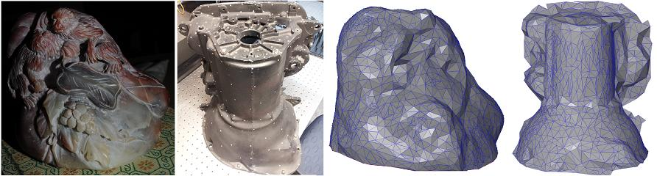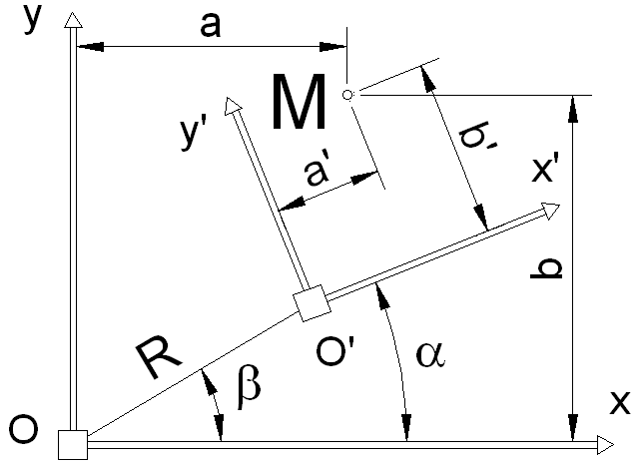
(a) (b)
Figure. 1: (a) Virtual model of the location, and (b) An image example of different nature
(Source: Johansen et al. (2012); illustrations modified with the Author’s written permission)
(Style of the paragraph: ‘<Figure caption’; Times New Roman, 8pt, Spacing: Before: 0pt, After: 0pt, no empty line below)
Images/photos embedded have to be in one of the following formats: JPG, TIFF and PNG (minimum of 300 dpi should be used). (Style of the following paragraph (if any): ‘<First paragraph’; Spacing: Before: 6pt, After: 0pt; no empty line below).

Tables (style of the paragraph: ‘<heading1’; All letters capitalized; Times New Roman, 10pt, Bold, Spacing: Before: 12pt, After: 6pt, no empty line below)
The table layout must be according to that in the example below. Each Table should be centred. Tables must not be in the form of spread-sheets but WinWord created. (Style of the paragraph: ‘<First paragraph’; Table-filling Style: ‘<Table filling’; The font in the Table: Times New Roman, 8pt, Italic, Spacing, Before: 0pt, After: 0pt; No empty lines before and after the table).
Table 1: The parameters defined for different tests
(Source: Johansen et al. (2012); Table reproduced with the Author’s written permission)
(Formatting-Style: ‘<Table title’; 8 pt, Bold, Spacing: Before: 12pt, After: 6pt, no empty line below)
Site | Adjusted  R2 | Mean error (m) | Standard deviation  of error (m) | % of points  ‘‘good’’ | % of points  ‘‘fair’’ | % of points  ‘‘poor’’ | Codes of points interpolated
Full site | 99.96 | 0.320 | 0.154 | 16.7 | 40.9 | 31.6 | 10 B 8
Sub-scene | 98.32 | 0.310 | 0.165 | 25.7 | 27.9 | 35.2 | 11 B 2
The paragraph after the table (if any): Style of the following paragraph (if any): ‘<First paragraph’; Times New Roman, 10pt, Regular, Spacing: Before: 6pt, After: 0pt; No empty lines after the table).

Mathematics (style of the paragraph: ‘<heading1’; All letters capitalized; all the style details as previuosly described)
To respect proper mathematical conventions as well as to minimise the Author’s effort including that on the part of the copyeditors, the usage of Math-Editor is suggested. Equation positioning (without naming) should be centred (as follows): (Style of the paragraph '<First Paragraph'; all the style details as previuosly described).
$$v=L^{−1}{\left({\text{BLB}}^{T}\right)}^{−1}\text{Ax}+w$$
(Style of the following paragraph (if any): ‘<New paragraph’).

Page-Breaking Rules (style of the paragraph: ‘<heading1’; All letters capitalized, all the style details as previuosly described)
There must not be empty/blank rows between consecutive single- and multi-line sections, except in the case of respecting following ‘Page-breaking rules’ that Author(s) has to apply in the final text-processing pass. (Style of the paragraph '<First Paragraph'; all the style details as previuosly described).
Those ‘Page-breaking rules’ are:
- No headings may be located at the bottom of a page - without a minimum of 2 ending rows of subsequent text: if else, the headings must be pushed up to the very top of the next page,
- In case of enumeration, at least one numbered (or bulleted) item should be placed immediately after the introductory sentence at the same page. If it is not possible, the introductory sentence should be moved to the beginning of the following page, and
- The last page must be completed at a rate of at least 50%.

Important note
Let us repeat that the extended abstract should not exceed two pages (including necessary figures, tables and keywords). We also wish to remind you that the deadline for Extended Abstract submission is 22. April 2016.
Keywords: computer graphics; descriptive geometry; photogrammetry; computer science; applied geometry (Style of the paragraph 'Keywords'; Times New Roman, 10pt, Regular, Spacing: Before: 6pt, After: 6pt, no empty line below)
- NOTE: All the text that is presented in color is just for instruction, and should be deleted.

